Pre-registration: Phi motion report task

Motivation
This experiment aims to examine how phi motion is reported, serving as a comparison group for the colour phi illusion. This comparison investigates whether colour change is the reason why participants do not typically perceive motion when seeing the colour phi illusion stimuli.

Methods

Participants
200 participants will be recruited from Prolific.com, filtered for intact corrected vision, no colour-blindness, English as first language, a prolific study approval rate above 95%, and not having participated in previous experiments in this project. The experiment lasts around 5 minutes, and participants will be paid 80p, approximately equivalent to £9.6/hour.

Procedure

Stimuli details
The stimuli are designed to mirror the colour phi illusion stimuli used in the original experiment (Kolers & von Grunau, 1975), except that the two shapes share the same colour. Specifically, two flashes appear, which are either two squares with side lengths measuring 0.9 visual angles or two equilateral triangles of the same area. The colours are sampled from the colour phi illusion report task, including red, blue, yellow, and green. They are separated by 3.6 visual angles between their midpoints, each appearing for a duration of 150 ms. A time interval of 50 ms, in which the screen appears empty, occurs between the two flashes. 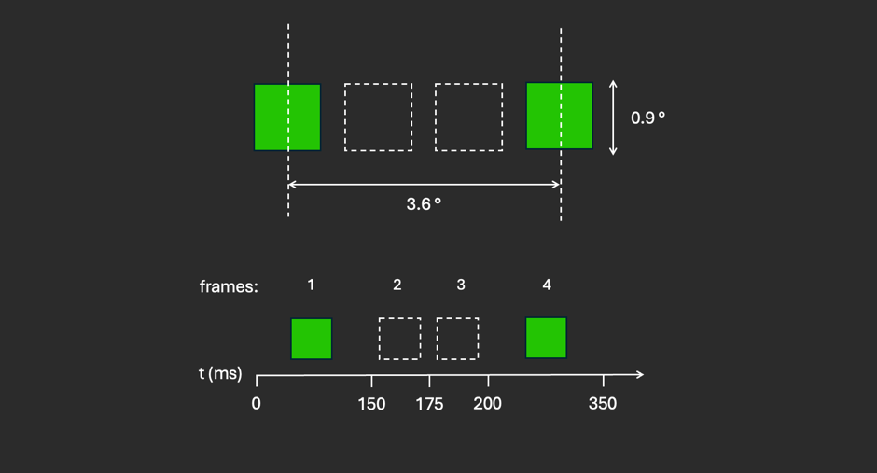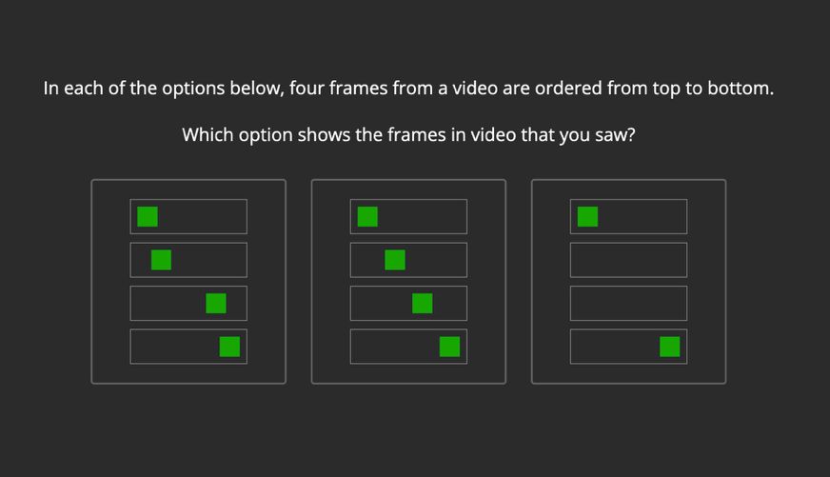
Figure 1: Stimulus parameters Figure 2: Frame sequences

Experiment design
Participants first complete a consent form. They then complete a screen size and visual angle estimation using JsPsych’s plugin “virtual chinrest”. This involves two phases: in phase one the pixel to cm conversion is measured by resizing an image to match the size of a credit card; in phase two the viewing distance is measured with a blind spot task.
Then, participants are told that they will be shown a video and asked to pay close attention:
“In this experiment, we will show you a video on the screen for a brief moment. You will need to pay close attention: the entire video will last less than a second! You will then be asked to describe what you saw in detail.”
To help participants focus, a reference region is displayed on the screen at the location where stimuli will be played:
“The grey rectangle indicates the area where the video will be displayed. Once you press “continue”, the video will start.”
After one second, the phi motion stimuli is presented inside the reference region. Participants will then be given an open text box to report what they saw. They will only be able to submit their response once they write at least 20 words. We will then ask, “How many shapes were in the video?”, allowing participants to respond with any number. Finally, we ask, “Please choose, between the following options, which is the video that you saw.” Here, the options are illustrations of three frame sequences (see Fig. 2). The order of the three options is randomized between participants.

Randomization
All participants are allocated to the same condition; no randomization will occur.
Data analysis

Rejection criteria
Participants will be rejected if they report not having seen the stimulus at all or if their report of what they saw does not feature geometric shapes. Participants will also be excluded if the experiment records frames not being displayed on their monitor.

Hypotheses and analysis plan
The data from this task will be analysed with the responses from the colour phi illusion condition in a previous task. In the colour phi illusion condition, all questions asked and the stimuli used are identical to here, except for that the two flashes are shown in different colours. The same verbal reports and shape number reports are collected across these two tasks. Three different hypotheses will be tested, all concerning a difference between proportions in the two conditions. They will all be tested with independent-samples Z-tests. We will use the standard p < .05 criterion for significance.
H1 [motion reports]:
From the verbal reports, we will extract whether the participants refer to a movement. We test the null hypothesis that, in the phi motion task, the proportion of participants reporting motion will not be significantly different from the proportion in the colour phi illusion condition.
H2 [shape number perception]:
From the reports of the number of shapes seen, among the participants who report seeing either one or two shapes, we extract the proportion of participants reporting seeing one shape. We test the null hypothesis that the proportion of participants seeing one shape will not be significantly different between the phi-motion task and the colour phi-motion condition.
H3 [frame sequence type]:
We test the null hypothesis that the proportion of participants choosing a frame sequence with in-between frames (i.e., 4 frames) will not be significantly different between the phi motion task and the colour phi illusion condition.

Sample size justification
We use a sample size of 200 participants. The difference between this sample of participants and the colour phi illusion condition that can be detected depends on proportion in one condition. Assuming 5% of participants report motion in the colour phi illusion condition, we will have a statistical power of 95% to detect an effect size corresponding to a proportion of 16% in this task.

References:
Kolers & von Grunau. (1975). SHAPE AND COLOUR IN APPARENT MOTION’.

